PROJECT STRUCTURE

**TEAM ID : PNT2022TMID22988**

**PROJECT NAME : A Novel Method for Handwritten Digit Recognition System**

Create a folder which contains files as shown below

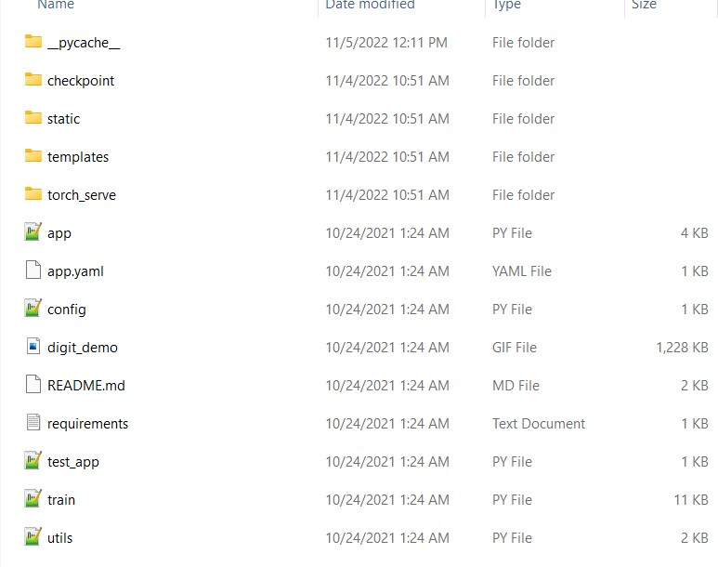

* We are building a Flask Application which needs HTML pages stored in the templates folder and a python script app.py for server side scripting.
* The model is built in the notebook Hand written recognition train.py
* We need the model which is saved and the saved model in this content is mnist
* The static folder will contain css and jquery files.
* The templates mainly used here are main.html and index6.html for showcasing the UI.